Video Wheels Off

Quantico

[Phoebe Lam](mailto:phlam@twilio.com)

<https://wiki.hq.twilio.com/pages/viewpage.action?spaceKey=~spalmer&title=%5BTraining%5D+Work+to+be+Completed+during+Onboarding+and+before+Video+Wheels-Off#id-[Training]WorktobeCompletedduringOnboardingandbeforeVideoWheelsOff-Quantico>

Using a SQL Query, find your API Request for the compositions you created. Add SQL Query and a shareable link to Google spreadsheet with the results from Quantico to a GitHub Document.

**Account SID:** ACc060dfd7ef14fb5f023a92786bf150b1

Query

SELECT *

FROM `qtco-customer-support.prod.app_api_access_last_3_days`

WHERE account_sid='ACc060dfd7ef14fb5f023a92786bf150b1'

AND uri = '/Compositions'

ORDER BY timestamp DESC

LIMIT 1000

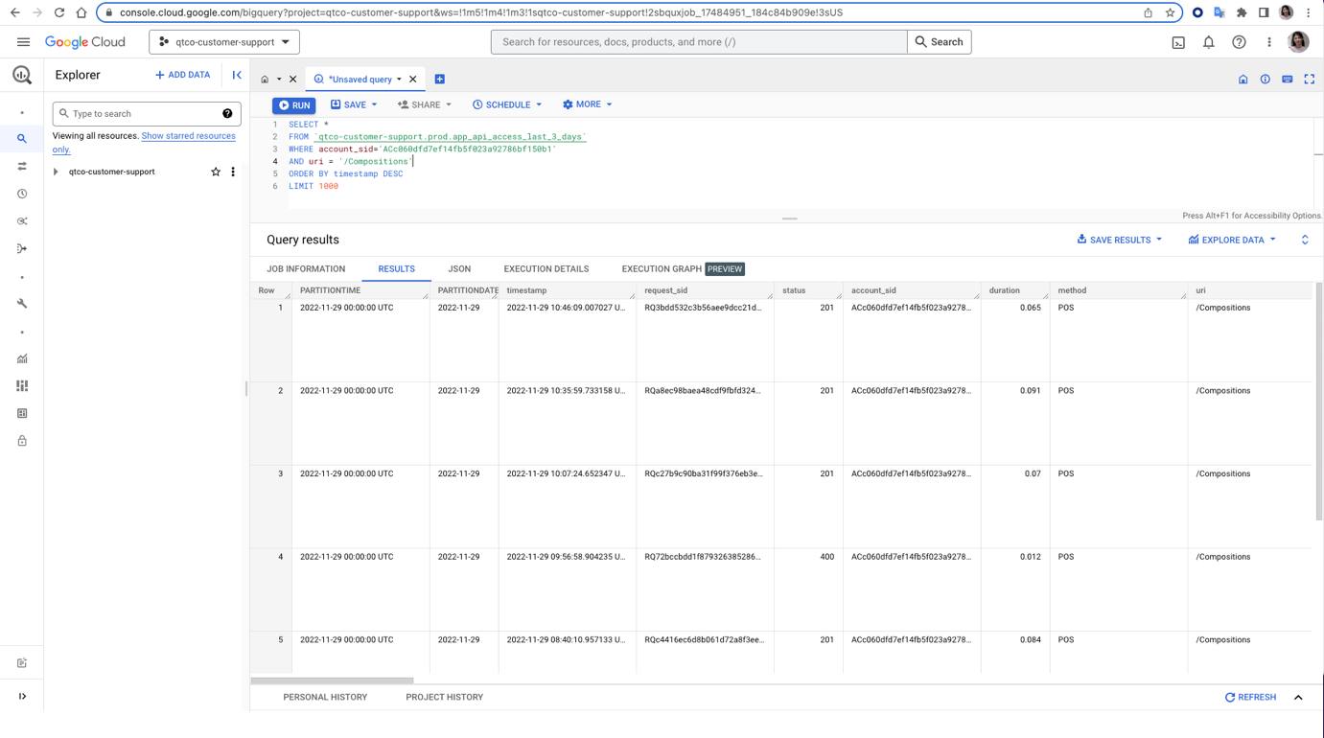

<https://console.cloud.google.com/bigquery?sq=359385078535:e42f5c04124447c791c264b94d972fe7>